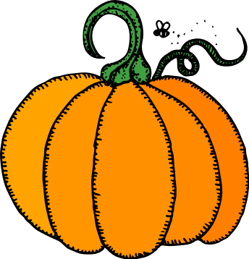
This year at Brown we will be having classroom Halloween parties on the 31st beginning at 3 p.m. We will play games, have snacks, and make posters for “Trick or Treat for UNICEF,” a third grade action project. At this time, we don’t need any help organizing this event, as we will use class funds to purchase the food. We will be mindful to accommodate students’ food allergies. There will not be a school parade and no costumes please.

The third grade is visiting the Pompeii Exhibit at the Museum of Nature and Science on Monday, October 29 from 9 a.m.-2 p.m. We need parents to help chaperone this field trip. We would like at least 5 parents to accompany each class. Please contact your child’s teacher to confirm your participation.

Also, the cost for each child to attend this field trip is $3. Please have your child bring in their money by, Wednesday, Oct. 24th. We are not sure how many chaperones we can get in for free, so please be prepared to pay the entrance fee.

Thank you for helping make the Fall Festival a big success!

Math
As we move into learning more about measurement, please give your child the opportunity to measure with rulers, measuring tapes, and yard sticks at home. In addition, it is important that students practice their math facts at home. Please work on accuracy and speed.
Math
As we move into learning more about measurement, please give your child the opportunity to measure with rulers, measuring tapes, and yard sticks at home. In addition, it is important that students practice their math facts at home. Please work accuracy and speed.
Important Dates
Currently in reading students are working on the reading skills of identifying main idea and supporting details. When writing a main idea sentence, students have been taught to use the acronym WIN to help them.
W- Who or What is the text is about?
I-What is the most important information?
N- Write a sentence with the above information with the least number of words.
Students will be using the skill of identifying main idea and supporting details to write expository summaries.

Reading and Writing
Field Trip to Museum of Nature and Science
No School! Fall Break
Nov. 21-23
No School! Thanksgiving Holiday
Halloween Parties in classrooms. There will be no parade. No costumes please.
No School! Veteran’s Day Observed
Nov. 12
Oct. 31
Oct. 29
Oct. 25-26

October Happenings

Volunteers Needed

Conferences
Oct. 22-23

Halloween Party

